Name: Jorune Simpkins
Lab: 1C_bonus_E
Document Topic: Student Deliverables
Date: 2/1/2026
Part 1 of 2

4) Student verification (CLI)
A) Confirm WAF logging is enabled (authoritative)
aws wafv2 get-logging-configuration \
--resource-arn <WEB_ACL_ARN>
4. OUTPUT
$ aws wafv2 get-logging-configuration \
--resource-arn "arn:aws:wafv2:us-east-1:975598471165:regional/webacl/armageddon-final-waf01/1b272192-4ee6-4df0-a16d-8983b34c3b03"
{
"LoggingConfiguration": {
"ResourceArn": "arn:aws:wafv2:us-east-1:975598471165:regional/webacl/armageddon-final-waf01/1b272192-4ee6-4df0-a16d-8983b34c3b03",
"LogDestinationConfigs": [
"arn:aws:s3:::aws-waf-logs-armageddon-final-975598471165"
],
"ManagedByFirewallManager": false,
"LogType": "WAF_LOGS",
"LogScope": "CUSTOMER"
}
}

Expected: LogDestinationConfigs contains exactly one destination.

B) Generate traffic (hits + blocks)
curl -I https://chewbacca-growl.com/
jorun@Simpkij3421 MINGW64 ~/documents/theowaf/armageddon/armageddon_repo/armageddon_clone/1c_bonus_E (main)
$ curl --ssl-no-revoke -I https://firstpointand.click/
curl: (6) Could not resolve host: firstpointand.click
curl -I https://app.chewbacca-growl.com/
NOTE: I only created a hosted zone for app.firstpointand.click. Therefore, the root domain will never resolve.
############################################
# Bonus B - Route53 (Hosted Zone + DNS records + ACM validation + ALIAS to ALB)
############################################
locals {
# Explanation: armageddon needs a home planet—Route53 hosted zone is your DNS territory.
armageddon_zone_name = var.domain_name

# Explanation: Use either Terraform-managed zone or a pre-existing zone ID (students choose their destiny).
armageddon_zone_id = var.manage_route53_in_terraform ? aws_route53_zone.armageddon_zone01[0].zone_id : var.route53_hosted_zone_id

# Explanation: This is the app address that will growl at the galaxy (app.armageddon-growl.com).
armageddon_app_fqdn = "${var.app_subdomain}.${var.domain_name}"

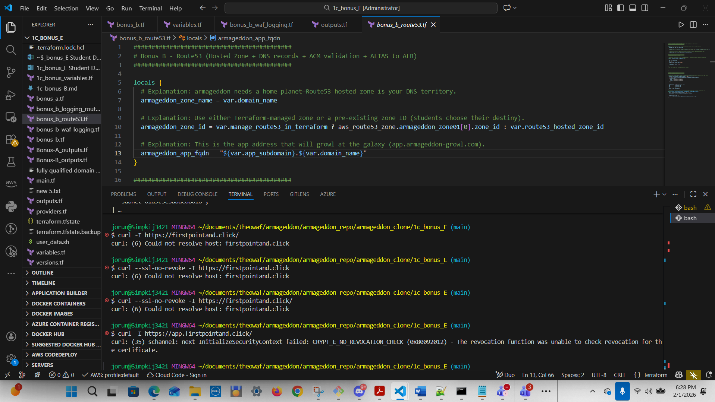

curl -I https://app.firstpointand.click/
curl --ssl-no-revoke https://app.firstpointand.click
jorun@Simpkij3421 MINGW64 ~/documents/theowaf/armageddon/armageddon_repo/armageddon_clone/1c_bonus_E (main)
$ curl --ssl-no-revoke https://app.firstpointand.click

<h1>Lab 1b: Simple RDS App</h1>
<ul>
<li><a href='/init'>1. Init DB</a></li>
<li><a href='/add?text=LabEntry'>2. Add Note (?text=...)</a></li>
<li><a href='/list'>3. List Notes</a></li>
</ul>
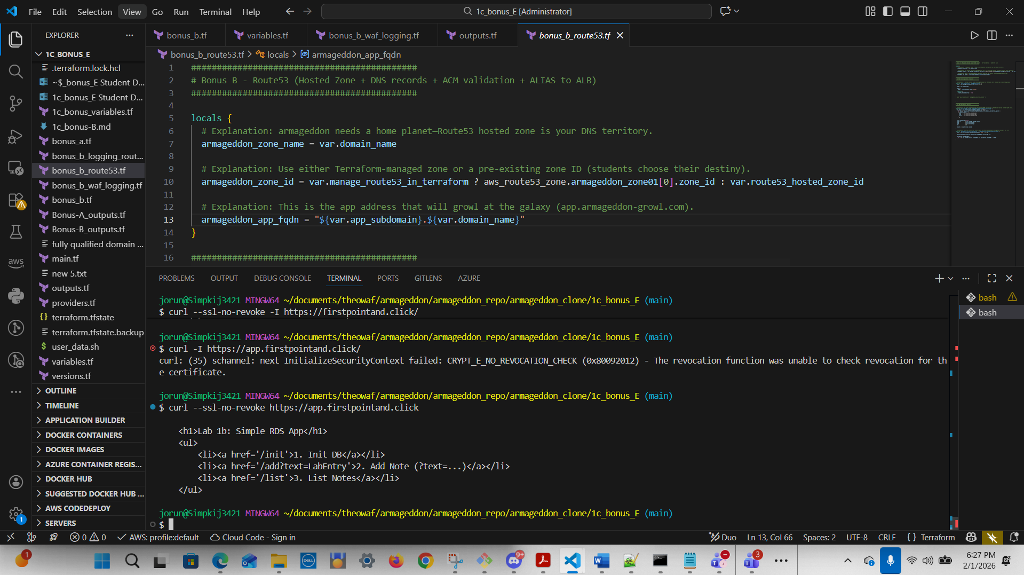

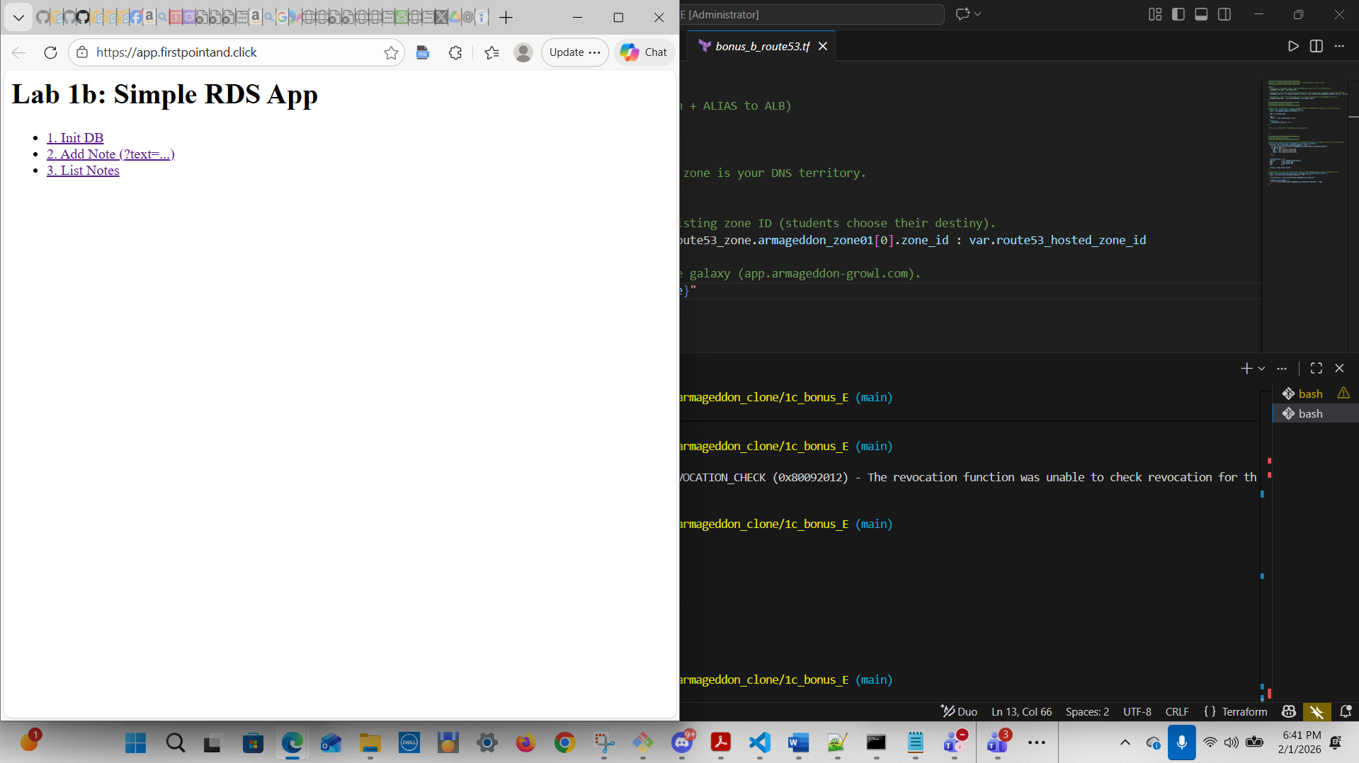

C1) If CloudWatch Logs destination - NOTE: Chose S3 Destination
aws logs describe-log-streams \
--log-group-name aws-waf-logs-<project>-webacl01 \
--order-by LastEventTime --descending

Then pull recent events:
aws logs filter-log-events \
--log-group-name aws-waf-logs-<project>-webacl01 \
--max-items 20

C2) If S3 destination
aws s3 ls s3://aws-waf-logs-<project>-<account_id>/ --recursive | head

C2. OUTPUT (S3 destination):
C2 If S3 destination
aws s3 ls s3://aws-waf-logs-armageddon-final-975598471165/ --recursive | head
jorun@Simpkij3421 MINGW64 ~/documents/theowaf/armageddon/armageddon_repo/armageddon_clone/1c_bonus_E (main)
$ aws s3 ls s3://aws-waf-logs-armageddon-final-975598471165/ --recursive | head
2026-02-01 17:44:49 0 AWSLogs/975598471165/
2026-02-01 17:48:52 1023 AWSLogs/975598471165/WAFLogs/us-east-1/armageddon-final-waf01/2026/02/01/22/45/975598471165_waflogs_us-east-1_armageddon-final-waf01_20260201T2245Z_d9c8fd74.log.gz
2026-02-01 17:53:52 1140 AWSLogs/975598471165/WAFLogs/us-east-1/armageddon-final-waf01/2026/02/01/22/50/975598471165_waflogs_us-east-1_armageddon-final-waf01_20260201T2250Z_a442b54e.log.gz
2026-02-01 18:03:53 783 AWSLogs/975598471165/WAFLogs/us-east-1/armageddon-final-waf01/2026/02/01/23/00/975598471165_waflogs_us-east-1_armageddon-final-waf01_20260201T2300Z_a8d0aeb4.log.gz
2026-02-01 18:08:52 663 AWSLogs/975598471165/WAFLogs/us-east-1/armageddon-final-waf01/2026/02/01/23/05/975598471165_waflogs_us-east-1_armageddon-final-waf01_20260201T2305Z_6d90ee61.log.gz
2026-02-01 18:18:53 876 AWSLogs/975598471165/WAFLogs/us-east-1/armageddon-final-waf01/2026/02/01/23/15/975598471165_waflogs_us-east-1_armageddon-final-waf01_20260201T2315Z_e0b1aac6.log.gz
2026-02-01 18:23:53 629 AWSLogs/975598471165/WAFLogs/us-east-1/armageddon-final-waf01/2026/02/01/23/20/975598471165_waflogs_us-east-1_armageddon-final-waf01_20260201T2320Z_b06c7af5.log.gz
2026-02-01 18:28:53 1156 AWSLogs/975598471165/WAFLogs/us-east-1/armageddon-final-waf01/2026/02/01/23/25/975598471165_waflogs_us-east-1_armageddon-final-waf01_20260201T2325Z_9f4a4789.log.gz
2026-02-01 18:33:53 671 AWSLogs/975598471165/WAFLogs/us-east-1/armageddon-final-waf01/2026/02/01/23/30/975598471165_waflogs_us-east-1_armageddon-final-waf01_20260201T2330Z_75d127e8.log.gz
2026-02-01 18:43:52 1324 AWSLogs/975598471165/WAFLogs/us-east-1/armageddon-final-waf01/2026/02/01/23/40/975598471165_waflogs_us-east-1_armageddon-final-waf01_20260201T2340Z_4f6d2fda.log.gz

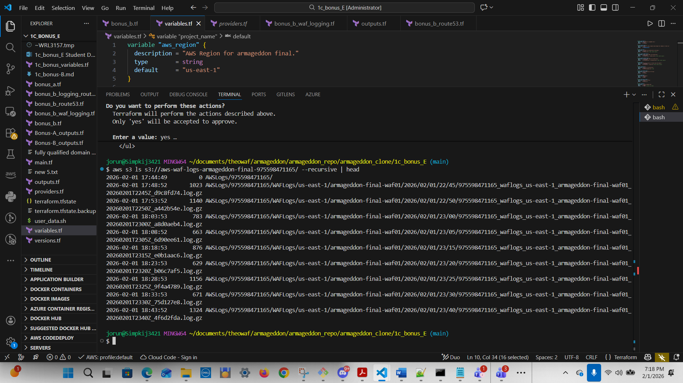

C3) If Firehose destination
aws firehose describe-delivery-stream \
--delivery-stream-name aws-waf-logs-<project>-firehose01 \
--query "DeliveryStreamDescription.DeliveryStreamStatus"

And confirm objects land:
aws s3 ls s3://<firehose_dest_bucket>/waf-logs/ --recursive | head

5) Why this makes incident response “real” – See Part 2 for answers
Now you can answer questions like:
“Are 5xx caused by attackers or backend failure?”
“Do we see WAF blocks spike before ALB 5xx?”
“What paths / IPs are hammering the app?”
“Is it one client, one ASN, one country, or broad?”
“Did WAF mitigate, or are we failing downstream?”

This is precisely why WAF logging destinations include CloudWatch Logs (fast search) and S3/Firehose (archive/SIEM pipeline)

